**Visual Design and Styling:**

**1. Define Color Scheme:**

* Choose a color palette that aligns with your personal brand. Aim for 2-4 main colors and variations (shades or tints) for accents.
  + Neon blue = #2272FF;
  + Black = #1D1D1;
  + White = #FFFFFF;
  + Dark Classic Blue = #0A1828;
  + Downy Teal = #6ACFC7; Cardin Green = #0C1A1A;
* Use tools like Adobe Color or Colors to generate harmonious color schemes.

**2. Typography:**

* Select a pair of fonts for headings and body text. Google Fonts offers a wide variety of fonts that are easy to integrate.
  + [Adelle with Avenir Next:](https://typ.io/s/bf9d)

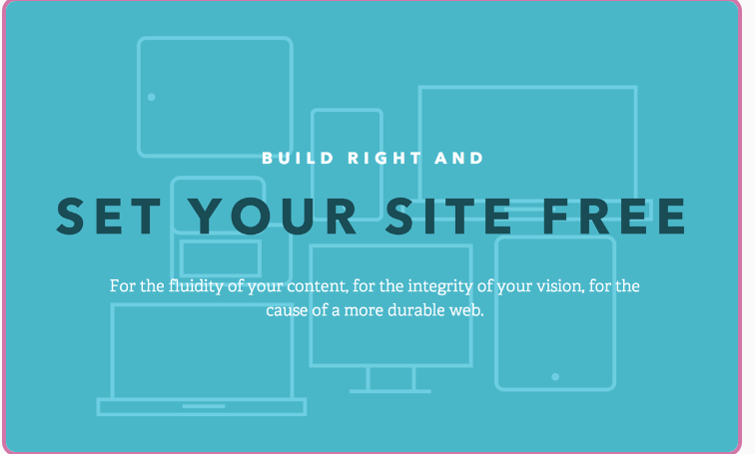

* + [Open Sans with Raleway](https://typ.io/s/tnfm) - [Lato](https://typ.io/s/2h74)

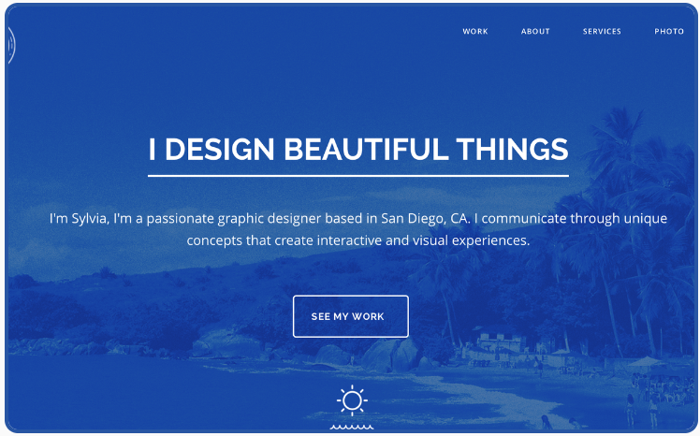 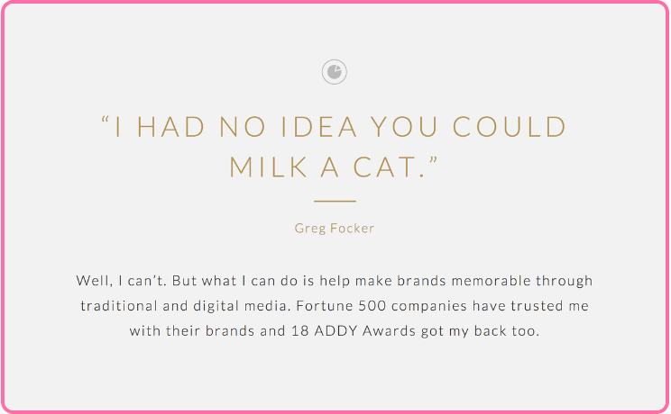

* Use a legible font size (e.g., 16px for body text) and maintain consistent typography throughout your site.

**3. Layout and Spacing:**

* Employ a responsive layout using CSS Grid or Flexbox to ensure your website looks good on different screen sizes.
  + [2.1__CSS Mobile Responsive Grid + Flexbox__.docx](2.1__CSS%20Mobile%20Responsive%20Grid%20+%20Flexbox__.docx)
* Use consistent spacing between sections, elements, and margins to create a balanced design.

**4. Navigation:**

* Create a navigation bar with links to different sections of your portfolio (e.g., About, Projects, Contact).
* Use CSS to style the navigation bar, ensuring it's easily accessible and user-friendly.

**5. Header:**

* Add a header section at the top of your page with your name or logo.
* Apply a background image, color overlay, or simple design elements to enhance the header's visual appeal.

**6. About Me Section:**

* Introduce yourself and provide a brief overview of your background, skills, and interests.
* Use engaging typography and spacing to make this section visually appealing.

**7. Projects Showcase:**

* Create a grid or a series of cards to showcase your projects. Include project titles, images, and descriptions.
* Apply hover effects to project items to provide interactivity and enhance user experience.

**8. Contact Information:**

* Provide a section where visitors can contact you. Include a contact form or direct links to your email and social media profiles.

**9. Footer:**

* Add a footer at the bottom of the page with copyright information and links to privacy policy or terms of use, if applicable.

**10. CSS Styling:**

* Use CSS to apply your chosen color scheme, fonts, and styles to different elements.
* Utilize CSS classes and IDs to target specific elements for styling.
* Implement CSS transitions or animations for subtle effects (e.g., smooth hover transitions).

**11. Mobile-Friendly Design:**

* Ensure your design is responsive and looks good on mobile devices. Test your website on different screen sizes.

**12. Testing and Refinement:**

* Test your website on various browsers and devices to ensure consistent appearance and functionality.
* Gather feedback from others to identify areas for improvement.